AI Powered Procurement & Vendor Management System
Make.com | Airtable | Google Sheets | Google Drive | Gmail | Slack | OpenAI | DocuSign | Webhooks

Project Overview
Built an automated procurement and vendor management system for handling purchase requests, vendor onboarding, quotation comparison, approvals, purchase orders, and delivery tracking.
The workflow takes a new purchase request and turns it into a complete procurement process with automated budget checks, vendor evaluation, approvals, document management, and final delivery verification.
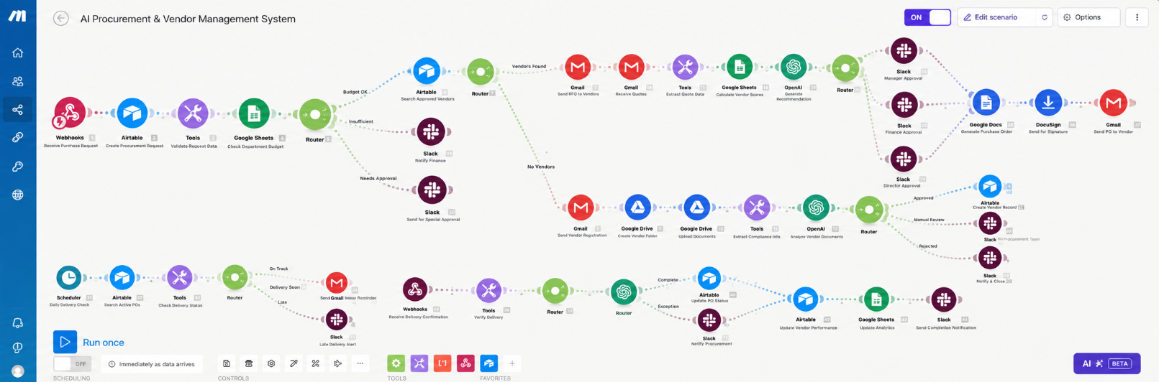
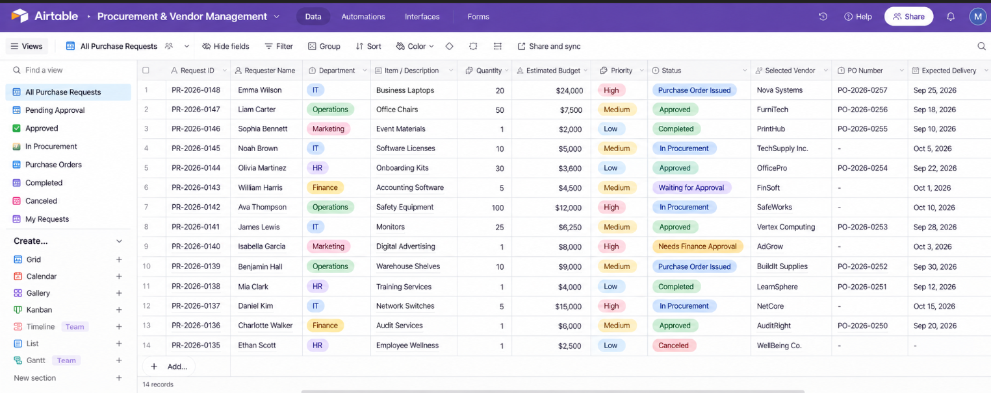
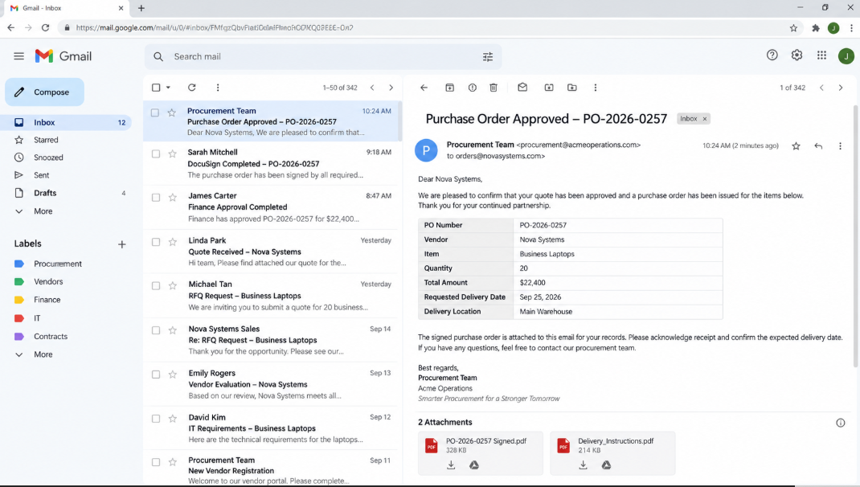
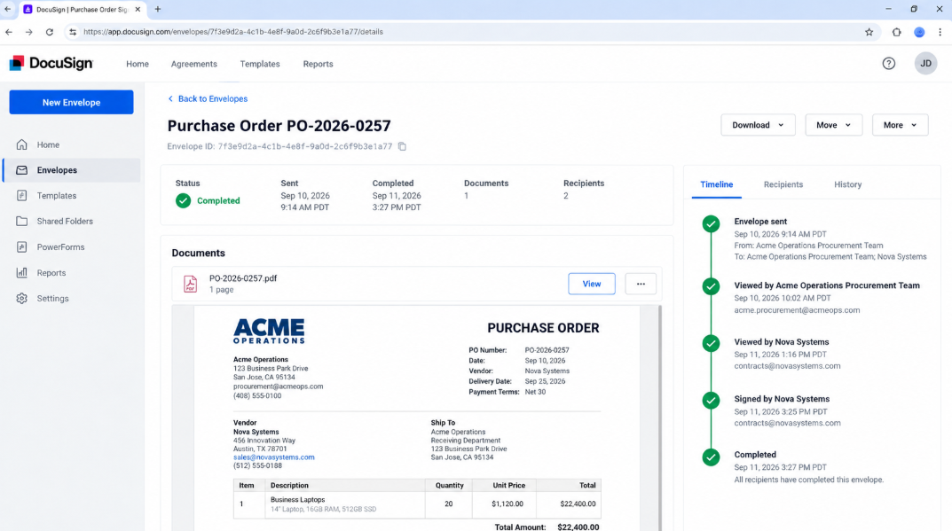

Workflow
The system:
- Receives purchase requests through a webhook
- Creates and validates procurement records automatically
- Checks department budget before processing
- Searches approved vendors based on the requested category
- Starts vendor onboarding when no suitable vendor is available
- Creates vendor folders and stores compliance documents in Google Drive
- Extracts and analyzes vendor documents using AI
- Calculates vendor compliance scores and approval status
- Sends RFQs to approved vendors automatically
- Receives and stores vendor quotations
- Extracts pricing, delivery, warranty, and payment terms from quotes
- Compares vendors using weighted scoring
- Generates an AI based vendor recommendation
- Routes purchases through manager, finance, and director approvals
- Generates the final purchase order automatically
- Sends documents for digital signature through DocuSign
- Sends the approved purchase order to the selected vendor
- Tracks active purchase orders and delivery deadlines
- Sends reminders and late delivery alerts
- Verifies received goods against the original order
- Updates vendor performance and procurement status
- Updates procurement analytics automatically

Branding & Templates
The workflow uses predefined procurement, RFQ, approval, and purchase order templates.
Each template controls:
- Vendor communication
- RFQ structure
- Approval requests
- Purchase order details
- Delivery notifications
This keeps the procurement process consistent across different departments and vendors.

Content Management
Airtable acts as the central procurement and vendor tracking system.
Each request is updated with:
- Request status
- Budget approval
- Selected vendor
- Vendor score
- Purchase order number
- Approval status
- Delivery status
- Vendor performance

Technology
- Make.com
- Airtable
- Google Sheets
- Google Drive
- Gmail
- Slack
- OpenAI
- DocuSign
- Webhooks

Result
A complete automated procurement pipeline that turns a purchase request into an approved, documented, signed, tracked, and completed purchase order without requiring teams to manually manage every procurement step.
The system also keeps vendor documents, quotations, approvals, delivery status, vendor performance, and procurement analytics organized in one workflow.

